Language production is variable; even talkers with similar language backgrounds express different categorization bounds in their phoneme production (e.g., the amount of spectral energy use to differentiate /s/ from /ʃ/) [1]. Therefore, listeners' perception of language must be flexible to accommodate variation. This flexibility allows us to understand newly encountered talkers speaking in a shared language, despite a lack of knowledge regarding that talker’s production tendencies [2-3]. Our ability to adapt to novel talkers is seemingly automatic; a large body of research supports that perceptual adaptation (PA) is not inhibited by distractions, lack of intention, or exposure to multiple talkers [4-6]. The goal of this experiment is to explore what factors moderate PA flexibility, specifically if attentional resources constrain how talker productions are internalized. If the malleability of PA is contingent on the allocation of attentional resources, then listeners should adjust to a talker’s production tendencies if and only if the listener is directing their attention towards that talker’s verbal stream.

To investigate this question, we observe listeners’ PA performance in the context of the cocktail party problem. The cocktail party problem refers to how a listener is able to engage with a singular voice in a multi-voice environment. In this experiment, we seek to replicate the cocktail party effect as a means of limiting listeners’ available attentional resources and introducing a goal-directed behavior. To this end, we developed a novel dual-talker paradigm in which two distinct simulated talkers speak simultaneously *(figure 1)*. These talkers produce inversely atypical pronunciation variants on the S-ʃ continuum (i.e., one talker produces their /s/ sounds more like “Sh,” and the other talker produces their /ʃ/ sounds more like “S”), effectively shifting the categorization boundary between /s/ and /ʃ/ in opposite directions compared to the average L1 English speaker. In the exposure phase, participants (n=60) were instructed to listen to one of the two talkers and perform a series of lexical recognition tasks *(figure 2)*. In the test phase, we then gauged listeners’ PA of both talkers through a set of lexical discrimination tasks.

Contrary to our prediction, we found a lack of significant (p>0.05) PA *(figure 3)*. However, consistent accuracy throughout the lexical recognition tasks suggests that participants were able to effectively separate the two verbal streams during the exposure phase, proving that lexical access did occur. A potential explanation for these results is that variation in spectral energy production may have been attributed to noise. Our findings support that there are limits to the automaticity of PA. Furthermore, our findings may suggest that available attentional resources mediate our ability to internalize/integrate lower-level speech input, or that lower-level phonetic perception is potentially moderated by higher-level cognitive judgements. Further research is necessary to elucidate how higher level executive functioning influences lower-level speech perception recalibration.

**[1]** Appelbaum, I. (1996). The lack of invariance problem and the goal of speech perception. In *Proceeding of Fourth International Conference on Spoken Language Processing*. ICSLP 96 IEEE. **[2]** Kleinschmidt, D. F., & Jaeger, T. F. (2015). Robust speech perception: Recognize the familiar, generalize to the similar, and adapt to the novel. *Psychological Review*, 122(2), 148–203. **[3]**  Norris, D., McQueen, J. M., & Cutler, A. (2003). Perceptual learning in speech. *Cognitive psychology*. <https://doi.org/10.1037/a0038695> **[4]** Zhang, X., & Samuel, A. G. (2014). Perceptual learning of speech under optimal and adverse conditions. *Journal of Experimental Psychology: Human Perception and Performance*. <https://doi.org/10.1037/a0033182> **[5]** Kraljic, T., & Samuel, A. G. (2007). Perceptual adjustments to multiple speakers. J*ournal of Memory and Language*. **[6]** Cummings, S. N., & Theodore, R. M. (2022). Perceptual learning of multiple talkers: Determinants, characteristics, and limitations. *Attention, perception & psychophysics*. <https://doi.org/10.3758/s13414-022-02556-6>

*figure 1 (left):* A visual of how the Critical Words spoken by Talker A and Talker B are divided into Materials A and Materials B. In this experiment, the words in Materials A are produced with an ambiguous sound and the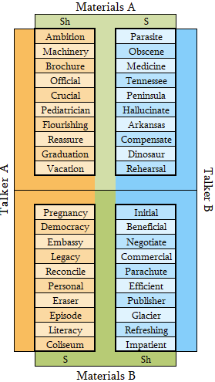

words in Materials B are produced with an unambiguous sound. During the Critical Trials, each Talker is always heard in the same ear (e.g., Talker A in the Left Ear and Talker B in the Right Ear).

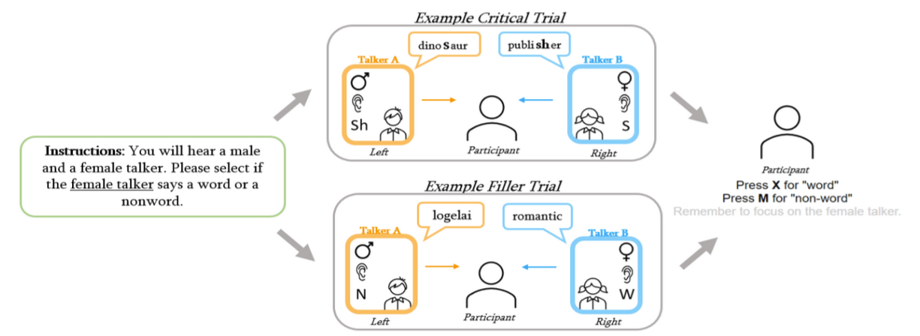

*figure 2 (above, right)*: A visual diagram of a single trial. Participants will be instructed to attend to either the male (♂) or female (♀) talker at the beginning of the experiment (left, green box). One talker will be presented in the left ear, and the other in the right ear. Each subsequent exposure trial will feature two talkers, either in a critical trial (top) where both talkers produce a word that contains an /s/ or /ʃ/ sound, or a filler trial (bottom) where one talker produces a word (W) and the other a nonword (N). The participant must then select if the Attended Talker produced a word or a nonword for each exposure trial.

*figure 3 (above):* The average proportion of ASHI responses by Test Item for the Attended Talker (blue) and the Unattended Talker (orange). Responses are separated by the ambiguous sound production; in the left panel, the Attended talker produced an ?s, and the Unattended Talker produced an ?sh sound. The inverse is true in the right panel. Each point correlates to the calculated average number of ASHI responses for a given Test Item. The shading around the calculated psychometric curve represents a 95% confidence interval. The gray dashed line marks where the proportion of ASHI responses equals 50%. Where the curves intercept this line represents the estimated perceptual boundary for the Talker, when participants are equally likely to judge the production as ASI or ASHI for a given Test Item.